
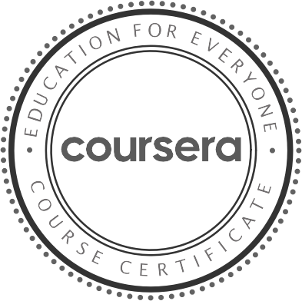
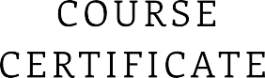
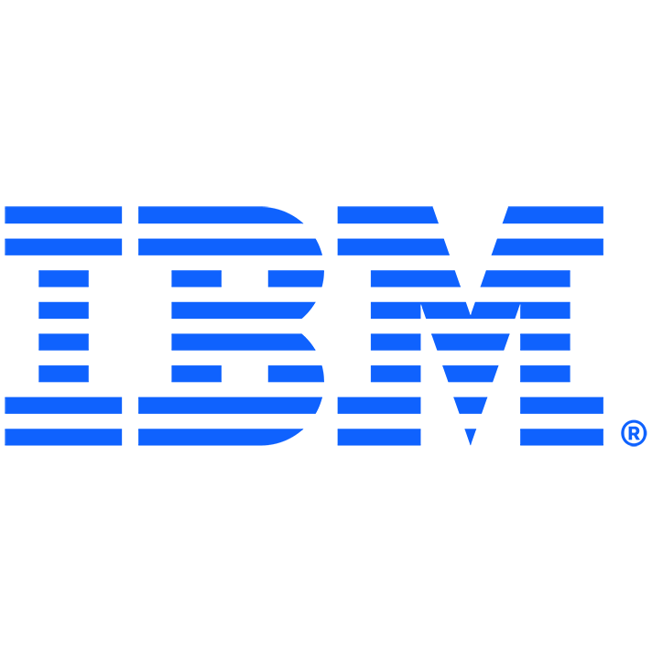
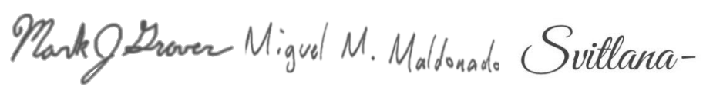

Nov 1 , 2025

SUKMA ARIF WIBOWO SUKMA

has successfully completed

Supervised Machine Learning: Regression

an online non-credit course authorized by IBM and offered through Coursera

Mark Grover Miguel Maldonado Lana Kramar

V er i fy at: https://cour ser a.or g /v er if y /M1RBHOFGCTAW
C ou r ser a h as con f ir med th e id en tity of th is in d iv id u al an d
th eir p ar ticip ation in th e cou r se.

